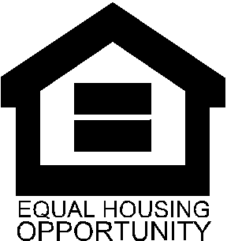
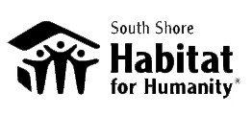
Family Partnership Program
Are you looking for an opportunity to buy a simple, decent, and affordable home?
43 Elm Street Cohasset

3-bedroom, 1.5 bath 2nd Floor Condo in converted 2 family home with approx. 1,500 sq. ft.
2016 Condo Fee: $304.00/month, year converted: 1993

$76,762.00

Application Deadline 4:00 PM Tuesday May 31, 2016
No Exceptions.

Size of  Family | Maximum Annual Income
1 | $51,150
2 | $58,450
3 | $65,750
4 | $73,050
5 | $78,900
6 | $84,750
7 | $90,600
8 | $96,450
 | *Subject to change annually
Individuals/families will be accepted into the Habitat Family Partnership Program based on the following guidelines:
- Ability to repay a 0% interest mortgage
- Annual income of at least $30,000
- Annual income not to exceed the maximum per family size (80% AMI) as determined by the Department of Housing and Urban Development (HUD) – See Chart*
- Willingness to partner with South Shore Habitat, including 100 - 200 sweat equity hours volunteering for Habitat
- Willingness to attend homeowner workshops & financial literacy classes
- Level of housing need as determined by your current living conditions

Qualified families who are approved in to the Family Partnership Program will be eligible to apply for the 0% Interest Mortgage to purchase a Habitat home. Families will be chosen without respect to age, gender, sexual preference, disability, race, religion or national origin.

For more information visit: www.sshabitat.org, email nbrowne@sshabitat.org or call 781.337.7744 x 10

Applications for the Family Partnership Program are available for pick up at the
Cohasset Public Library – 35 Ripley Road Cohasset, MA, South Shore Habitat office in Weymouth or can be downloaded from the website.

Selection for the Family Partnership Program is based on the following criteria:
- Ability to Pay – Your ability to repay home mortgage.
- Need – Your family’s housing need based on the suitability of your current housing.
- Willingness to Partner – Your willingness to participate as a Family Partner with Habitat.
1. ABILITY TO PAY
You must meet income guidelines. Habitat serves families whose incomes do not exceed more than 60% of the area median income. The Department of Housing and Urban Development (HUD) determines the area median income, which is subject to change annually.

Since you will be purchasing your home from Habitat, you must demonstrate your ability to make the monthly mortgage payments. These payments will include not only the mortgage payment, but also payments for real estate taxes and insurance, and in the case of condominiums, a monthly condo fee. Habitat mortgage payments do not exceed 30% of your annual household income. We will require you to fill out an application, we will request a credit check from an independent agency, and require verification of your income.

2. NEED
You may be considered for a Habitat home if your present housing is not adequate, and if you are unable to obtain adequate housing through conventional means. Lack of adequate housing may include, unsafe living conditions, problems with the housing structure, electrical, plumbing or heating, or overcrowding (more than 3 family members sharing a bedroom). Additionally, consideration may be given to those who have housing costs that are excessive in relation to your annual income.

3. WILLINGNESS TO PARTNER WITH SOUTH SHORE HABITAT FOR HUMANITY
If selected and approved, you become a “Family Partner.” As a Family Partner, you must complete “sweat equity” hours. These hours may be completed through a variety of ways including, construction of a Habitat home, participation in homeowner education classes, and participation in affiliate activities. As a Family Partner, you must complete 100 hours of sweat equity. In some instances, if a partner is disabled or otherwise unable to do physical labor, the Habitat office will work out a modified alternative plan. From the time you move into your home, you will be responsible for maintenance and repairs of your home. Once you are approved as a Family Partner, you are encouraged to maintain an on-going relationship with South Shore Habitat for Humanity.

Families will be chosen without respect to age, gender, sexual preference, disability, race, religion or national origin.

